**Most people do not care enough about environmental issues.**

**To what extent do you agree or disagree?**

Environmental problems have always been a hot topic for debating in recent years. I think it is definitely true because the majority of people were not conscious of the importance of the environment issues. From my perspective, I totally agree that many people do not care enough about the environment.

On the one hand, environmental problems may not have a huge impact on individuals. There were numerous people, who did not like to go out for jogging, did not pay attention about the environment atmosphere. As a result, they did not want to help garbage reduction or plastic-consuming campaigns and they would have bad awareness of the environment. For example, residents understand that observing a trash in the street is wrong, but they do not want to take their responsibility to clean that. In addition, people were too lazy to mind the environment issues. This led to the consequence that they have been tired of making their houses cleaned and this also made them think that workers who did the cleaning should take their job.

On the other hand, there still exist a great deal of people who concern about the environmental difficulties. People who were educated as a kid tended to be aware of the environment. Although it was just a little about the world, it might a good opportunity for them to find their interest. For instance, a few of them would find a job or hobby such as cleaning the houses, attending global environment campaign, volunteering works and many more. Additionally, there are so many advertisements, events to let them know how vital it is to conserve the environment.

In conclusion, it is noticeable that many people are careless about environmental crises for many ways. I suppose that people should not ignore the environment and put more effort on studying about the environment.

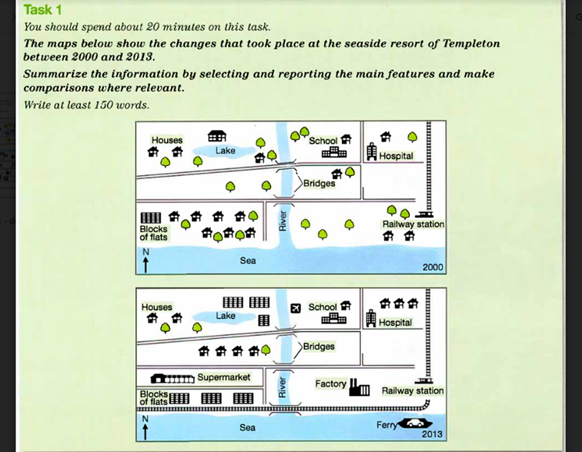

The maps illustrate the difference of the seaside resort of Templeton between 2000 and 2013.

Overall, it is noticeable that there were numerous houses in 2000 and they were destroyed and replaced by blocks of flats, factory and supermarket in 2013.

In 2000, the seaside resort of Templeton was a much greener area with a number of trees and individual houses, but during the next 13 years it experienced a great deal of changes. The most developments is that all of the trees east of the river were cut down, with all the constructions along the railway line were devastated and replaced by factory. Furthermore, a hospital, a school and bridges stayed in the same place throughout the years.

Only a few trees west of the river remained. There were several constructions around lake and it were replaced by blocks of flats. In the center of the two bridges plenty of houses were built. Moreover, the railway station has expanded through the river and to the west of the river.